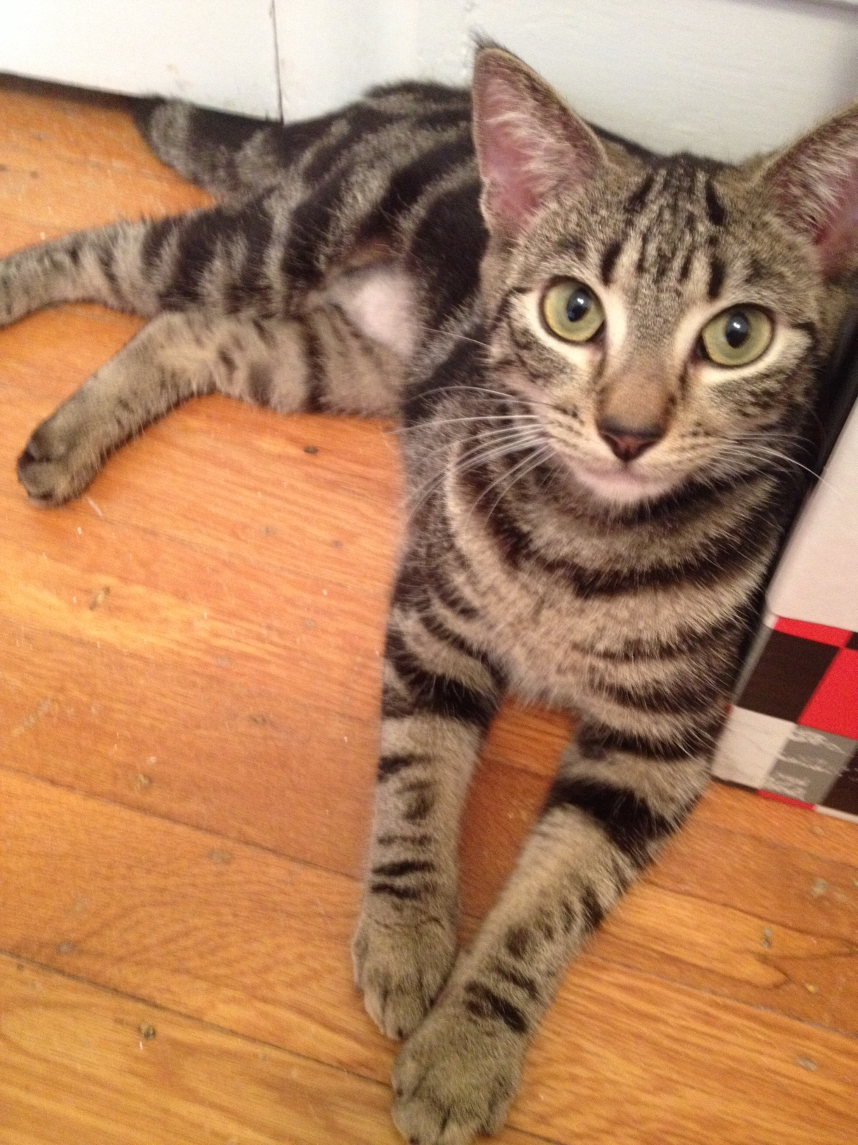
Please Adopt Me

Include background information:
- Name
- Age
- Gender
- Medical history (e.g., spayed/neutered, vaccinated)
- Household preferences (e.g., gets along/doesn’t get along with kids, dogs, cats)
- Personality (e.g., likes to play, cuddly)
- Reason you are giving the cat up
Vet or personal references required.
Adoption fee of $XX.

Adopt [name of cat]  Contact [your name]:  [phone or email address] | Adopt [name of cat]  Contact [your name]:  [phone or email address] | Adopt [name of cat]  Contact [your name]:  [phone or email address] | Adopt [name of cat]  Contact [your name]:  [phone or email address] | Adopt [name of cat]  Contact [your name]:  [phone or email address] | Adopt [name of cat]  Contact [your name]:  [phone or email address] | Adopt [name of cat]  Contact [your name]:  [phone or email address]

